Alberta’s Natural Regions
Partner: ___________________ Region:________________________
This semester our Social Studies class has focused on the geographical location of Alberta. With a partner, you are going to examine one of the six regions of Alberta more in depth.
This assignment is research based, which means you will have to use books, magazines, computers, blogs, etc to discover new information about your region. Topics you may want to consider are:

- Geography
- Natural Resources
- Vegetation
- Climate
- Animals
How do the elements of physical geography, natural resources, vegetation and climate affect how people live (e.g. occupation, diet, recreation)?
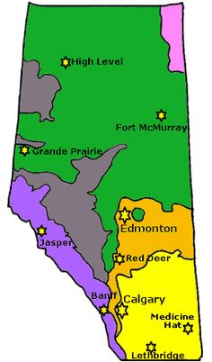
Here are some things you should consider when doing your assignment:
- What makes a good presentation?
- What should your viewers learn from your presentation?
- What pictures should you include in your presentation?
- What facts should you record on your presentation?
- Have I shown where my geographical region is in Alberta?
- Are there any major bodies of water or landforms I should represent?
Presentation ideas:
- Powerpoint
- Poster
- Pamphlet
- Diorama
- Paper

Criteria | Excellent | Proficient | Acceptable | Limited
I can describe major geographical and natural vegetation regions, landforms and bodies of water in Alberta  (4.1.2) | Assignment displays thorough and accurate information about region chosen. Includes detailed information on landforms and bodies of water. | Assignment displays complete and accurate information about region chosen. Includes information about landforms and bodies of water. | Assignment displays basic information about region chosen. Includes some information about landforms and/or bodies of water. | Assignment does not display information about region chosen. Does not include information about landforms or bodies of water.
Oral, Written and Visual Literacy  (S.8) | Students put a great deal of effort into their poster. It is aesthetically pleasing and informative. | Students have put a great deal of effort into making their presentation aesthetically pleasing and informative. There may be some mistakes or neatness issues. | Students have put some work into poster neatness, but there may be some issues. Key words mis-spelled or lack of neatness. | Students have not put much effort into presentation.
Cooperation and Group Skills  (S.5) | Students showed exemplary group work skills. | Students showed proficient group work skills. | Students showed some positive group work skills. | Students did not show positive group work skills.
In Social Studies, we are learning to…
- Locate information to answer research questions, using a variety of sources, such as maps, atlases, charts, dictionaries, school libraries, video programs and field trips
- Paraphrase information from oral, print and other media sources
- Examine gathered information to identify if more information is required; review new understanding
- Identify strengths and areas for improvement in research process
- Demonstrate an understanding and appreciation of how elements of physical geography, climate, geology, and paleontology are integral to the landscapes and environment of Alberta
- Analyze how Albertans use natural resources and deal with competing demands on use of land

