Alberta’s Fossil Heritage (Chapter 2)

Learning Outcomes:
1. Appreciate the diversity of elements pertaining to geography, climate, geology and paleontology in Alberta
2. Appreciate how Alberta’s fossil heritage contributes to the provinces’ unique character

Assignment:
As we read through chapter 2 together and in small groups, you will be creating a Graffiti Poster to help record your information.
As you go, you will be asked to record the following information:
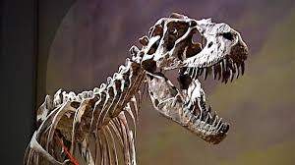
- Vocabulary Words
  - Fossils
  - Paleontologists
  - Iinisskimm (pronounced In-nis-kim)
  - Fossil fuels
2. Point form notes on:
- What fossils tell us about Alberta? (p. 48 &49)
- Where do fossils come from? (p. 50)
- Where are fossils found in Alberta? (p. 52)
- What was Joseph Tyrell’s big find? (p. 54)
- How are fossils protected? (p. 58)
- What is dinosaur provincial park? (p. 59)
- Royal Tyrrell Museum (p. 61)
- What are Fossil Fuels? (p. 62)
3. Hand drawn pictures, to show your learning! Any questions you have?

Marking Guide:
Excellent | Proficient | Basic | Not Yet
Demonstrates a comprehensive understanding of learner outcomes | Demonstrates a thorough understanding of learner outcomes | Demonstrates an understanding of learning outcomes at grade level with some support | Is not demonstrating an understanding of learner outcomes at grade level

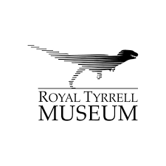
NOVEMBER 22nd at 1pm we will be VIDEOCONFERENCING with Royal Tyrrell Museum!

